**Team ID – ‘ELETRO ARMY’**

**Problem Statement – Address update**

**1} Kale Aditya Ashok –** [**aadityashokkale@gmail.com**](mailto:aadityashokkale@gmail.com)

**2} Jawale Samrudhi Balasaheb –** [**samruddhijawale2121@gmail.com**](mailto:samruddhijawale2121@gmail.com)

**3} Dhekane Abhishek Shivaji –** [**abhishekdhekane6@gmail.com**](mailto:abhishekdhekane6@gmail.com)

**4} Gaikwad Om Pravin –** [**omg01611@gmail.com**](mailto:omg01611@gmail.com)

**5} Date Gayatri Anil –** [**gaytridate@gmail.com**](mailto:gaytridate@gmail.com)

***ADDRESS UPDATE***

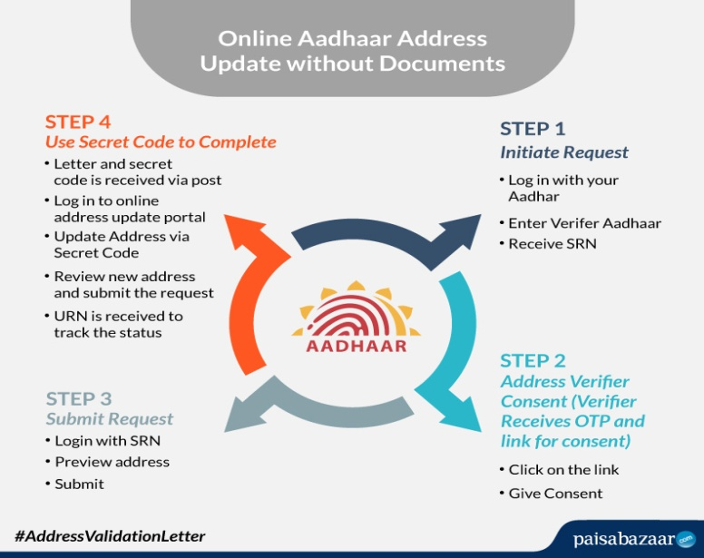

**Aadhar is a 12-digit unique number issued by the Unique Identification Authority of India (UIDAI) to the residents of India, on behalf of the Government of India. The Aadhar Card acts as a proof of identity and proof of address for residents of India.**

**But if you have relocated and want to change your address on your Aadhaar card, you can now easily do it by following four simple steps.**

**According to the official website of UIDAI, you will just need the Aadhaar number of the person who will act as a verifier for you. You must keep in mind that the verifier's Aadhaar number should have a mobile number registered with it.**

**Step 1: Initiate request from resident’s side**

-Log in to the UIDAI website with your Aadhaar number.  
-Enter the verifier’s Aadhaar.   
-You will receive SRN.

.

**Step 2: Verifier needs to give consent for the update**

-After receiving SRN, click to open the link.  
-Now, log in with the Aadhaar number or virtual ID.  
-Give consent.

**Step 3: Submit the confirmation received on your mobile**

-Now, log in with the SRN provided.  
-Preview the address submitted.  
-Edit local language and submit your request.

**Step 4: Use the secret code to complete the process.**

-After that, the resident will receive a letter with a secret code, via post.  
-Now login into the Online Address Update Portal.  
-Update your address with the help of a secret code.  
-Review the new address.  
-Note the URN for checking the further status.

**Step 5 : Take the help of GPS[global positioning system] for updating the address.**

**Step 6 : Make sure that your major changes in updating the address will not expiration.**

